What are some of the ways that can create more employment in rural and semi-rural areas?

More employment can be created in the rural and semi-rural areas:

• The government can spend some money to help farmers irrigate land. Banks can provide loans to people to carry out their work. The government can construct new dams and canals to irrigate farms leading to a lot of employment generation within the agricultural sector itself and reducing the problem of underemployment.

• The government can invest money in transportation and storage of crops, or make better rural roads so that mini-trucks reach everywhere The local banks should give credit at a reasonable rate of interest for farmers to buy seeds, fertilisers, agricultural equipments and pump sets to draw water, etc.

• The government should identify, promote and locate industries and services in semi-rural areas where a large number of people may be employed By giving boost to tourism as a sector and generating additional employment for more than 35 lakh people.

2. How is the tertiary sector different from other sectors? Illustrate with few examples.

• The tertiary sector different from other two sectors. This is because other two sectors produce goods but, this sector does not produce goods by itself.

• The activities under this sector help in the development of the primary and secondary sectors. These activities are an aid or support for the production process.

• For example, transport, communication, storage, banking, insurance, trade activities etc. For this reason this sector is also known as service sector.

Do you think the classification of economic activities into primary, tertiary and secondary is useful? Explain how.

• The classification of economic activities into primary, tertiary and secondary is useful on account of the information it provides on how and where the people of a country are employed. also this helps in ascertaining as to which sector of economic activity contributes more or less to the country’s GDP and per capita income.

• If the tertiary sector is developing much faster than the primary sector, then it implies that agriculture is depleting, and the government must take measures to rectify this. The knowledge that the agricultural profession is becoming unpopular or regressive can only come if we know which sector it belongs to. Hence it is necessary to classify economic activities into these there sectors for smooth economic administration and development.

Q Distinguish between.

Open Unemployment – When a country’s labour force do not get opportunities for adequate employment, this situation is called open unemployment. This type of unemployment is generally found in the industrial sector of our country. This is also found among the landless agricultural labourers in rural areas. • Disguised Unemployment – This is a kind of unemployment in which there are people who are visibly employed but actually they don’t have full employment. In such a situation more people are engaged in a work than required. This type of unemployment is generally found in unorganized sector where either work is not constantly available or too many people are employed for the same work that does not require so many hands.

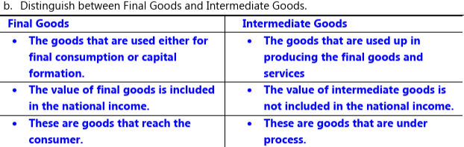

1. Imagine that you are the village head. Suggest any two activities that you think should be taken up to increase the income of villagers. (i) To develop water harvesting (ii) Development of irrigation facilities (iii) Development of Self-Help Group (iv) Development of animal husbandry (v) Development of infrastructural facilities. (vi) Development of cottage industries

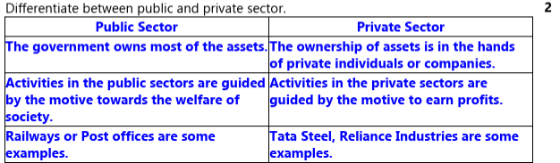

“The workers are exploited in unorganised sectors”. Explain any five disadvantages of working in this sector.

ADD RELEVANT INTRODUCTION AND CONCLUSION

1. In the unorganised sector there are rules and regulations but these are not followed.
2. ii. Jobs here are low-paid and often not regular.
3. iii. There is no provision for overtime, paid leave, holidays, leave due to sickness etc.
4. iv. Employment is not secure.
5. v. People can be asked to leave without any reason.
6. vi. When there is less work, such as during some seasons, some people may be asked to leave. vii. No other facilities like Provident Fund, Gratuity or sick leave is given.
7. viii. Working conditions are poor. No medical benefits are given.

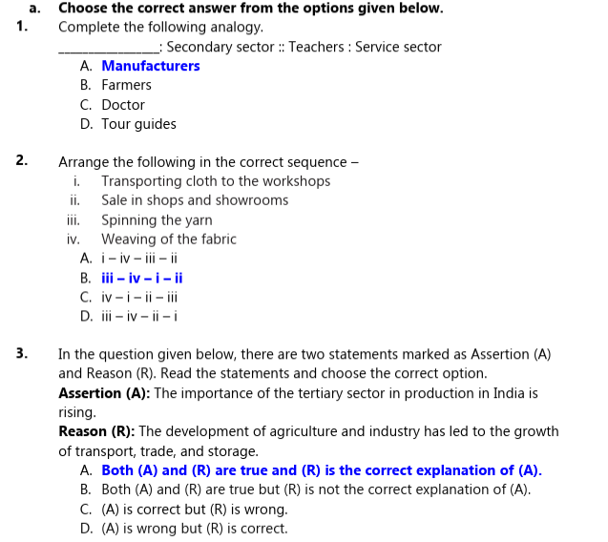

5. Choose the correct answer from the options given below. Complete the following analogy

. _________________: Secondary sector :: Teachers : Service sector

A. Manufacturers B. Farmers C. Doctor D. Tour guides

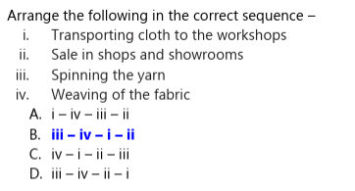

In the question given below, there are two statements marked as Assertion (A) and Reason (R). Read the statements and choose the correct option.

Assertion (A): The importance of the tertiary sector in production in India is rising. Reason (R): The development of agriculture and industry has led to the growth of transport, trade, and storage.

A. Both (A) and (R) are true and (R) is the correct explanation of (A).

B. Both (A) and (R) are true but (R) is not the correct explanation of (A).

C. (A) is correct but (R) is wrong.

D. (A) is wrong but (R) is correct.

When does underemployment occur?

A. When people do not want to work.

B. When people are working in a lazy manner.

C**. When people are working less than what they are capable of doing.**

D. When people are not paid for their work.

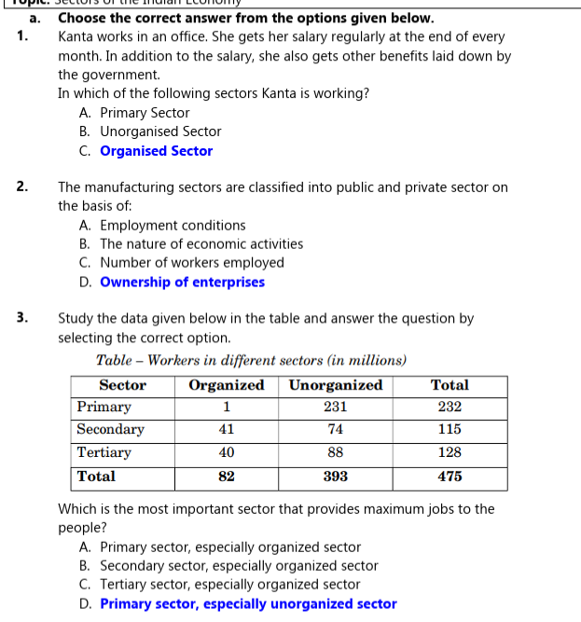

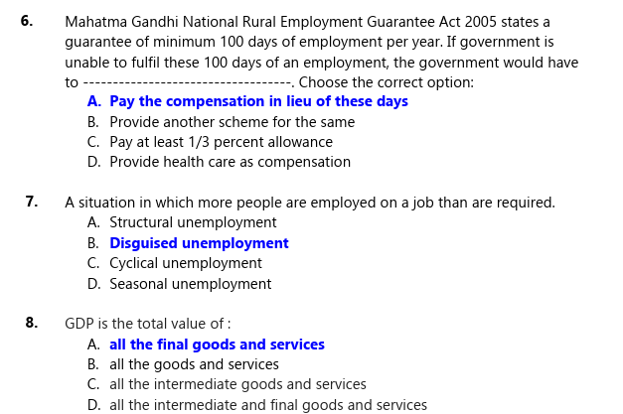

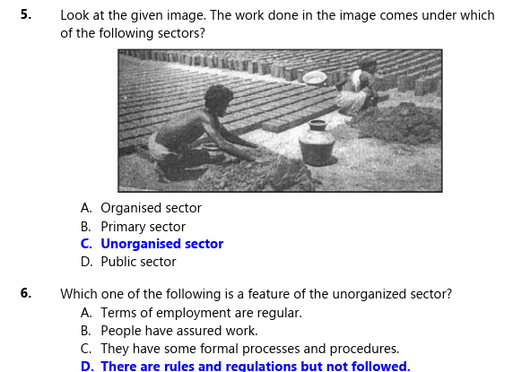

In the question given below, there are two statements marked as Assertion (A) and Reason (R). Read the statements and choose the correct option.

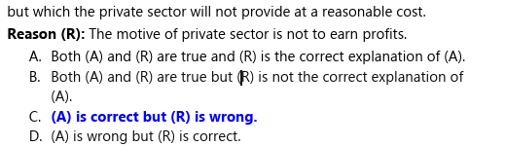

Read the source given below and answer the following questions.

Disguised unemployment is a situation in which people are employed but are not contributing to economic output. It is a common problem in India, where a large proportion of the workforce is employed in the agricultural sector. In agriculture, disguised unemployment occurs when there are too many people working on a small plot of land. This means that some of the workers are not needed and could be more productively employed elsewhere. Disguised unemployment leads to lower productivity and output in the agricultural sector. This is because workers are not working to their full potential.

Disguised unemployment contributes to poverty and inequality in India. This is because workers who are disguisedly unemployed are often paid low wages and have poor working conditions. Makes it difficult for the Indian government to achieve its economic goals. -Source: edited, World Bank (2023)

.1 What are the negative consequences of disguised unemployment for the Indian economy? (Any two)

Ans. Disguised unemployment leads to lower productivity and output in the agricultural sector. This is because workers are not working to their full potential. Disguised unemployment contributes to poverty and inequality in India. This is because workers who are disguisedly unemployed are often paid low wages and have poor working conditions.

5.2 Suggest any two ways through which employment for rural people can be generated.

• People can be employed in projects like construction of dam/canal/ roads in the village.

• Government invests and employs people in providing transportation and storage services.

• People can be employed in services like banking, trade, etc.

• Government can identify, promote industries and services in semi-rural areas to enhance employment.

• Government can open centres to give them training and financial assistance to help them become self-employed